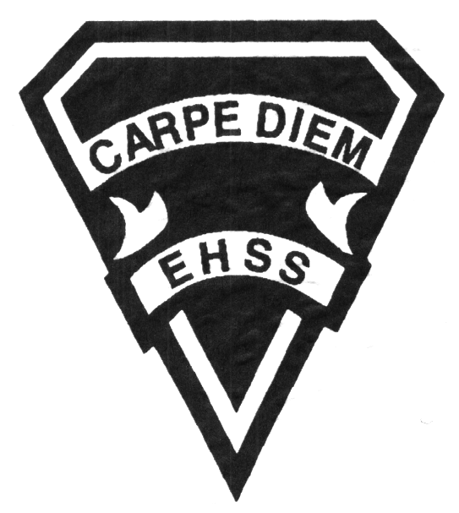

**2019/2020**

### Canadian and International Law

**Social Sciences Department**

## Earl Haig

SecondarySchool

# **CLN4U**

**Evaluation Profile & Outline**

**Course Description/Rationale/Overview:** This course explores elements of Canadian law and the role of law in social, political, and global contexts. Students will learn about the connections between the historical and philosophical sources of law and issues in contemporary society. They will also learn to analyze legal issues, conduct independent research, and communicate the results of their inquiries in a variety of ways.

**Class Requirements:** Students should have materials specified by the subject teacher at the beginning of the year.

The textbook for this course is Canadian and International Law. Students will be issued this book at the beginning of the course. The replacement cost for this textbook $135.00.

**Assessment and Evaluation Strategies**

Students will also be expected to complete assessment activities of a formative nature in order to learn and to practice the specific expectations that will compose the summative evaluations. Examples of formative assessment may include homework checks, quizzes, peer assessment, presentations, reflection writing, role-play scenarios and observation.

Each unit or strand of the course will be evaluated using summative evaluations. Examples of summative evaluations are tests, case studies, interviews, reports, presentations, seminars, debates, research and other writing assignments.

**Late and/or Missed Evaluation**

##### Late Assignments*

For each assignment, the teacher will inform students of the due date. The teacher may decide to create an ultimate deadline. If an assignment is submitted after the deadline, the teacher may deduct marks up to and including the full value of the assignment.

**Missed Tests**

It is the student’s responsibility to make arrangements, ahead of time, for any tests/quizzes that are missed. If a student misses a test/quiz for an unforeseen reason such as illness, the student must bring a note signed by a parent or guardian**. Alternatively a medical certificate may be requested by the teacher.** The student must be prepared to write the test/quiz immediately upon return to school at a time determined by the teacher. Once the tests/quizzes have been evaluated and returned, students will not be able to make up a missed test - a mark of zero will be assigned.

**Subject-Specific/Department Information**

Teachers in the Social Sciences Department can be reached at (416) 395-3210, ext. 20075 or 20085. Parents wishing to meet with a teacher are requested to make an appointment with the teacher prior to coming to the school.

**Learning Skills\***

**Responsibility** – meets deadlines; takes responsibility for own behaviour

**Organization** – establishes priorities and manages time; uses information, technology and resources top complete tasks time management

**Independent Work** – follows instruction with minimal supervision; uses class time appropriately to complete tasks

**Collaboration** – accepts an equitable share of work in a group; builds healthy peer relationships; works with others to achieve group goals

**Initiative** – looks for opportunities for learning; demonstrates curiosity; approaches new tasks with a positive attitude

**Self-regulation** – sets own goals and monitors own progress; seeks assistance with needed; makes an effort with responding to challenges

###### Final Mark

The final mark for this course will be determined based upon an accumulation of marks from unit summative activities and from a final summative evaluation

**Year’s Work 70%**

This is a culmination of evaluations that have been completed throughout the year. It may include tests, presentations, research, or topic specific assignments.

**Final Summative Evaluation 30%**

The summative activity will be an assignment (10%) and a comprehensive final exam based in concepts and themes presented during the course (20%).

**Achievement Categories and Weighting**

* **Knowledge / Understanding – 20%**

Knowledge of facts and terms; understanding of concepts, principles, guidelines and strategies; understanding of relationships among concepts.

* **Application – 30%**

Synthesizing knowledge and understanding into new and familiar contexts as well as making connections between various contexts.

* **Thinking Inquiry – 40%**

Formulating questions; planning, selecting strategies and resources; analyzing and interpreting information, and forming conclusions.

* **Communication – 10%**

Communication of information and ideas, communication for different audiences, use of various forms of communication.

*From: Ontario Ministry of Education. *Growing Success: Assessment, Evaluation, and Reporting in Ontario Schools*. Toronto: Ministry of Education, 2010, 11.



**2019/2020**

##### Canadian and International Law

**Social Sciences Department**

## Earl Haig

SecondarySchool

# **CLN4U**

**Evaluation Profile & Outline**

**Course Outline:**

###### 

Unit 1: Heritage

Students demonstrate their understanding of the historical and philosophical origins of law. They also demonstrate an understanding of the connection and relevance of the historical and philosophical origins of law to contemporary society. Different concepts, principles, philosophers, and theories of law are evaluated. Students demonstrate their understanding of the relationship between law and societal values. They assess the influence of individual and collective actions on the evolution of law.

Unit 2: Rights and Freedoms

Students demonstrate an understanding of the historical development of human rights legislation in Canada and explain the development of Canadian constitutional law. In their examination of the Canadian Charter of Rights and Freedoms, students develop an understanding of the rights and responsibilities of individuals. They explain the roles of the legislature and the judiciary in defining, interpreting, and enforcing Charter rights in Canada. Finally, students analyze the conflicts between rights and freedoms and between minority and majority rights in a democratic society and they describe the methods available to resolve these conflicts.

Unit 3: Criminal Law

Students analyze theories about criminal conduct and the nature of criminal behaviour. They explain what constitutes a crime in Canada and analyze Canadian criminal trial process. In their examination, students examine pre-trial procedures, the key features of the trial process, legally acceptable defenses to criminal conduct, and the types and purposes of sentencing. Finally, students demonstrate an understanding of the competing concepts of justice as they apply to the criminal justice system.

**Unit 4: Labour and Environmental Law**

Students explore the roles of government and citizens in two important areas of public law: the environment and the workplace. Students analyze legislation that affects both areas and develop an understanding of how citizens can have an impact as well.

**Unit 5: International Law**

Students look at the main concepts and principles of international law. Students use the concepts as a basis for investigating global issues in international law, as well as the agencies that currently enforce this law. Students assess the role of treaties and agreements in resolving international problems and use current events as a means of analyzing the complexity of world problems.